Tourist Behaviour Analysis

H.Mukund hariharan3

Dept of Networking and Communication

SRM Institute of Science and Technology

Kattankulathur, 603203, India

mh9482@srmist.edu.in

M.Nandha Kumar1

Dept of Networking and Communication

SRM Institute of Science and Technology

Kattankulathur, 603203, India

nm8573@srmist.edu.in

# Dev Singh1

D.Raghul2

Dept of Networking and Communication

SRM Institute of Science and Technology

Kattankulathur, 603203, India

rm8366@srmist.edu.in

*Dept. of Networking and Communication SRM IST*

# Kattankulathur, India ds4293[@srmist.edu.in](mailto:pm9969@srmist.edu.in)

R.Parthasarathi4

Dept of Networking and Communication

SRM Institute of Science and Technology

Kattankulathur, 603203, India

pr7809@srmist.edu.in

# Anshul Sharma4

*Dept. of Networking and Communication SRM IST*

# Kattankulathur, India ak1521@srmist.edu.in

Alok Kumar Sah2

*Dept. of Networking and Communication SRM IST*

# Kattankulathur, India as0091@srmist.edu.in

Dr. D Saveetha*

Dept of Networking and Communication

Faculty of Engineering and Technology

SRM Institute of Science and Technology

Kattankulathur, 603203, India

*Corresponding Author:

saveethd@srmist.edu.in

Dr.D Saveetha*

*Dept. of Networking and Communication SRM IST*

# Kattankulathur, India Corresponding author: saveethd@srmist.edu.in

Prajwal Thorat3

*Dept. of Networking*

*And Communication*

*SRM IST* Kattankulathur, India pt9682@srmist.edu.in

## *Abstract*— *The importance of the analysis of tourist behaviour in complicating the travelling experience and improving service delivery in the tourism sector is argued in this paper. With Apache spark behind handling large scale data reading, this project describes a complete data flow for modeling tourist behavior using machine learning approach based on big data platform. With Spark being the better big data processing tool; data are collected from different sources and preprocessed and then the relevant features are extracted. Secondly, machine learning algorithms are used to analyze behaviors,spending behaviors, spending trends of tourists. Google Colab is used to carry out data visualization, which makes it easier to do dynamic and interactive data visualizations and makes it convenient to present the results to the stakeholders. This document not only presents a feasible and extensible structure to apply for a wide range of tourism dataset to empower the making of the decision in tourism industry, but also to promote data processing and analyzing automation.*

***Keywords— Big Data, Apache Spark, Tourist Behaviour analysis, Machine Learning, Data Analytics,Data visualization.***

## INTRODUCTION

Currently the tourism industry gets exceedingly high since globalization and technological advancement have led here. For that reason, stakeholders interested in improving visitor experiences, reducing costs and practicing good marketing are interested in understanding the behaviour of tourists. By integrating new analytical big data approaches that will enable identifying pattern and trend unanswered by more conventional big data approaches, big data analytics in tourism research can be greatly enhanced.

Different sets of factors such as economic, cultural and environmental affects the behavior of tourist. Online travel platforms and duty free retailers have developed social media and mobile applications, therefore generating lots of data which tells many different stories around these behaviours. To get useful information out of this data however, it is needed.

It is hard to develop these analytical techniques. This is the basis for which this paper investigates the usage of machine learning algorithms as well as data visualization pertaining to using big data to analyze tourist behaviour.

To tackle computational jobs, we make use of Google Colab for its computational power, and drive advanced data visualization techniques to our understandig our complex datasets more clearly, to gain a better insights into tourist preferences and trends. In addition to this, we employ Apache Spark, a leading big data processing engine, to deal with huge quantities of data quickly and efficiently, thereby scaling the calculation not only in technical but also temporal dimensions.

We start with the preprocessing and analysing data collected from different platforms like social media feeds, travel reviews etc. We aim to provide insights by predicting tourist behavior using different analytical methods which could help policymakers and tourism operators make decisions. All these can help in developing a targeted marketing campaign, develop a better service offering and ultimately improving the overall tourist experience.

In addition to its repercussion on academic discourse of tourism analytics, this study presents practical implications of tuning tourist satisfaction and improving destination management. Using big data technologies we can convert raw data into actionable insights that result in more personalized and efficient tourism experiences.

Through that research, we show how big data technologies have the potential to help transform the understanding of tourism, and how big data can be incorporated into tourism business. In the spirit of bridging the gap between theory and practice, we have worked a path as a groundwork for future research and innovation in tourism analytics.

## RELATED WORK

In digital footprints can also be used to explore Chinese tourists' spatio-temporal behavior in Malaysia. The research shows that hotspots for tourism are unevenly distributed and thus there is high competition among the attractions. They extract tourist preferences and behaviors out of this complexity by combining complex network analysis with traditional methods, offering insight into preferred tourist behavior patterns, as well as ways in which marketing can be optimized and visitor experiences improved. With the rise of social media, there’s even more data sources to enrich, to put it simply, real time insights into tourist behavior. However, data privacy and bias problems exist, and this indicates that future research will require mixed method approaches. Tourism management strategies can be significantly improved using big data analytics [1].

The spatiotemporal behavior of Chinese tourists in Malaysia by analyzing user-generated content (UGC) on social media. Using a combination of deep learning techniques and Latent Dirichlet Allocation (LDA), they classified tourist sentiments from the photographic content of tourist posts made on Flickr and other similar platforms. Spatial distribution of tourist behaviors was mapped using Kernel Density Estimation (KDE) and seasonal and attraction preferences were discussed. The proposed methodology showcases the application potential for using the UGC for extracting insight into the tourist behavior pattern. Nevertheless, the spatial analysis in the study was limited to a specific tourist demographic, and failure to include other contextual factors such as local events and environmental conditions as part of the analysis was exposed [2].

Fine grained spatiotemporal analysis is possible now largely due to the emergence of high resolution geotagged photo data from platforms as Flickr in the tourism and urban studies. Jing (et al., 2020) argues for the use of Flickr data to better understand patterns of tourist movements and preferences, where such data is more detailed and more robust than other conventional sources, e.g. statistical yearbooks and surveys. Previous research has investigated in several ways aspects of urban tourism, but most have looked at macrospatial zones or large temporal variations. However, Jing et al. highlighted the need to study the monthly and daily variations, using techniques such as kernel density estimation (KDE) and space time cube for new visualization. The correlation analyses also have a qualitative and quantitative value to planners by offering a more precise, data driven perspective on tourism hotspots. Despite these contributions, we acknowledge limitations to data accuracy and parameter setting sensitivity and suggest that future research could further inform understanding of tourism popularity and the built environment or extend the use of Flickr data to incorporate textual and demographic insights [3].

The safety concerns of tourist crowdedness at high density in popular attractions. The result, their research showed, is that different types of travellers—particularly, female tourists at risk of an assault—are uniquely vulnerable. I focused on highly aggregated tourist crowds (HATCs), defined as groups of more than 50 individuals, all huddled in together in a confined space, and looked at what the complexities of managing safety in this kind of environment looks like. Some studies have been done on crowd dynamics and emergency evacuation but there is a knowledge gap on the designs of specific safety mechanisms for HATCs. Thus, recent investigations have identified factors affecting HATC safety and classified them into pressure factors, state factors and crowd management action(s). Researchers simulate different crowd scenarios to evaluate the safety status and construct effective early warning system in order to fulfill the need for tailored management strategies aimed at improving tourist safety [4].

The use of social network data to enhance the tourism demand forecasting ability. However, their research stressed the importance of obtaining real time consumer sentiment from social media, whereas traditional methods sometimes overlook. They integrated the structured variables like the weather and the holidays with social media data and then performed sentiment analysis using models such as BERT. They used Gradient Boosting Regression Trees to analyze Huang Shan and found that forecasting had much better accuracy than general methods did. Social network data was validated with ablation studies and were critical to improved tourism predictions, and served as a boundary for what the field considers innovative sources of data [5].

In researched Beijing tourism hotspot networks through geotagged Flickr data of Beijing and social media’s spatial data to understand travel intent.t. In previous research, the network in question was already known to present certain particular characteristics such as power law distributions, derived from global travel networks; in Miguéns and Mendes, the global travel network is considered first, followed by the protein network. Studies regarding tourist behaviour (using complex networks) testify to the value of network science in tourism systems, even if, as in Baggo et al. (2012). Based on the work of Wu et al., geotagged data can be used to produce a tourism hotspot network to assist route recommendations or guide tourism management strategy. Moreover, the application of complex network theory proves to be a consistently attractive nexus for the prediction of tourist trends and for more effective resource allocation in tourism. This method yields a better awareness of the interrelationship and interrelationship between different tourism elements to develop destination management and advertising techniques [6].

In looked into utilising geotagged travel photos from social media to locate tourist interests. Instead, their research suggests that user generated content on platforms such as Instagram, Flickr can be a source for tourist preferences and behaviors. The proposed framework uses geotagged photos to analyze geographic interests drawn to popular points of interest (POIs), providing a sustainable means of monitoring changes to tourist interests. This framework was validated in a case study in Hong Kong based on which its use can help get better tourism management and marketing strategies. This work is a complement in that it extends existing literature on the potential of using big data analytics to inform decisions in tourism by proposing a responsive approach to understanding and adapting to the changing interests of tourists. [7].

Travel route optimization using the stochastic approach with Markov chains under users' constraints in time, distance and popularity. We show the predictive power of Markov models to predict future user preferences based on historical data. Dijkstra and A* type algorithms are available, which enables several constraints of the users to our recommendations. Also, social media and geolocation data were established to capture the behaviour of tourists. According to Ahmad et al., adaptive models, that respond to changing user patterns, are better than static methods. This intersection of user centric design with machine learning and big data is starting to transform travel route optimization to provide a more tailored and more sustainable tourist experience [8].

The study found there remains a void in research regarding how to leverage big data to make strategic decisions for this industry. The completed assignment itself considered and provided an original method that builds from Design Science Research (DSR) technique that combines the analysis of the photos and the geotagged photo analysis with the text mining and geographic clustering. The application of this methodology was a good tool for studying the outcome of the tourist behavior patterns for Destination Management Organizations (DMOs). The study suggested that unstructured big data from Flickr and Facebook can provide valuable insights into tourist movements, preferences and experience. However, further application of this model to other ranges of available big data streams will further improve this model’s versatility and its real world applicability [9]

1. PROPOSED METHODOLOGY

**1. Data Collection**

The first step involves gathering extensive datasets from multiple sources. Tourist behavior data is collected from public repositories such as Kaggle and tourism research databases, containing detailed information on places, cities, attractions, best time to visit, notable features, visitor counts, and yearly trends. Datasets are stored in both structured formats (XLSX) and semi-structured formats (JSON).

Kaggle: Provides large datasets in XLSX format, covering details like place names, cities, popular attractions, visitor numbers, and the best time to visit various locations.

Tourism Research Databases: Offers detailed records in JSON format, including notable features of tourist spots, yearly visitor trends, and data on peak tourist seasons.

**2. Data Preprocessing**

After collecting the data for Tourist Behaviour Analysis, we then preprocess the data, clean and transform into a format that’s usable for machine learning. This step involves the following processes:

1. Data Cleaning

This means: eliminating or consuming missing values, handling anomalies, cleaning up ‘irrelevant’ columns (varying from useless feature to a few months ago visitor count). For example, imputation methods are used for guessing gaps in the visits, or for best time to visit columns.

2. Feature Engineering

It extracts of relevant features like place names, city names, attractions, notable features, etc., along with the visitor trend over several years. So we have built new features to understand average of fans per year, peak seasons through historical data and top attractions that changes behavior of visitor.

3. Normalization

In order not to introduce bias in your model training, you normalize your numerical data (e.g. number of visitors or year) in order to cover a uniform scale over diverse features. We can use some such techniques of feature incoherence, e.g. Min-Max scaling or Z-score normalisation.

4. Data Transformation

Data transformation simply means converting the dataset from multiple formats, such as XLSX, into the file formats that are compatible with the machine learning algorithm. It can include turning the tourist behaviour data into DataFrames, with libraries such as pandas that lets us quickly and efficiently process this data.Preprocessing with a structured approach ensures that there’s clean, relevant and usable data for deriving useful insights via machine learning techniques.

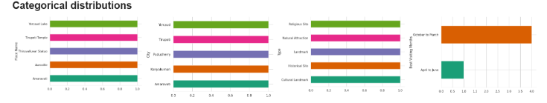

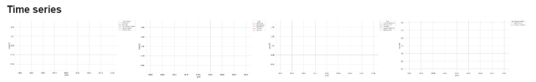

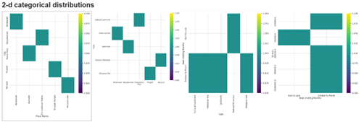

**Fig 1. This shows cleaned Data**

**3. Model Building**

Tourist Behaviour Analysis model building process then comes up with using of machine learning algorithm for predicting the tourist patterns and for tourist behaviour. Using the tools Apache Spark MLlib to efficiently process large scale datasets, we discuss several algorithms for this task.

1. Linear Regression

A Linear Regression model is developed on a baseline to predict visitor counts as a function of the best time to visit, notable attractions, and historical visitor trend. This model is easy to interpret and simple that are dependent on the input variable to target variable.

2. Random Forest Regression

Random Forest Regression has similar characteristics to an ensemble learner, which means that it creates multiple decision trees and takes average of its predictions. Now, this model will end up being selected to allow us to capture non linear relationship (or interaction) between features for a better prediction than simpler models will do. Especially for big numbers dataset with many features, because this allows to deal with overfitting.

3. Gradient-Boosted Trees (GBTs)

This is an example of one of the things that you need when you are doing ensemble classification, this is one particular type of ensemble learning that you have here: if you think about trees, you continue to grow trees, trying to correct the errors made by other trees they do that to you sequentially. However, empirically, it is very difficult to predict, so we replace it with a solidifying in the difficult to predict situations that significantly upscale the model accuracy and convert the model into a real model of tourist behaviour in the complex traffic.

4. Optional: Clustering Algorithms

In addition to regression model, the tourists can be classified on the basis of behavior and preferences for categorization using clustering algorithm such as K Means. It presents tailored customer marketing strategies and talks about the variations between the different tourist profile.

5. Model Evaluation

It then analyzes the models and how accurate and reliable it is to its prediction on Mean Absolute Error (MAE),Mean Square Error (MSE) and R squared value.

With this structured approach of model building, it is helpful to perform wide explanation of tourist behaviour for some useful insights of influencing decision making and tourism management strategy.

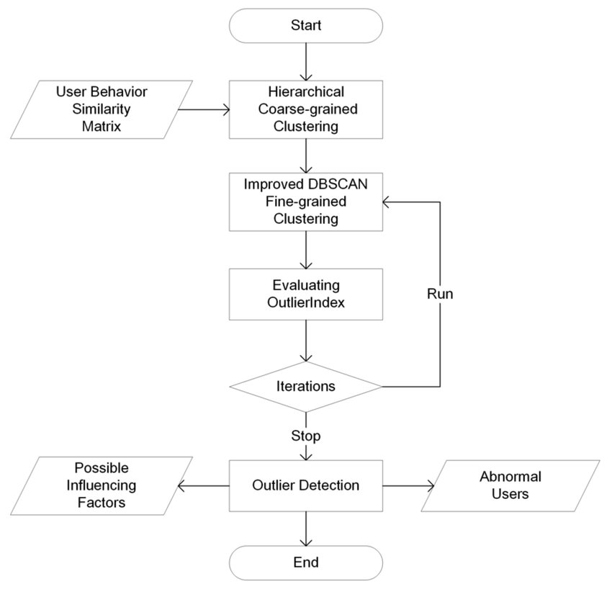

Fig 2.Flow chart for Model Building

**4. Model Training and Evaluation**

The model is trained on historical tourist behaviour data, split into training and test set. However, we use cross validation to tune the hyperparameters but it generalizes well unseen data. The following steps are used during training:

1. Train-Test Split:

The respective models are modeled to perform on dataset split into training (80%) and testing (20%) sets, and this is evaluated. It also allows us to test the model with data this model has never seen before, which is something to look into in how well this model can be used to predict future tourist trend trend.

2. Hyperparameter Tuning:

In the way, grid search and Random search are used to find out best result that we could get using model paramétres but all use technique there. For instance:Next, Parameters for tuning Random Forest model number of trees are tuned.In the case of Gradient Boosted Trees model (tuned t build in overfitting, but stealing maximum accuracy) parameters are: learning rates.

3. Evaluation Metrics:

The performance of the models is evaluated using various regression metrics, including:

Root Mean Square Error (RMSE):

Squared differences between the predicted and actual values averaged. Furthermore, it also graphs the size of the error for the prediction of the number of tourists.

Mean Absolute Error (MAE):

The quantification of a simple interpretable metric that serves as a prediction accuracy in the tourist numbers is provided in the tourist numbers scenario.

R-squared (R²):

This tells us how well the model explains the variation in the dependent variable (dependent variable) varies, i.e. how well we visited the visitors. The value of R² is higher this time, meaning that, this time, the model is closer to the data (closer to providing the time trends of the tourist).

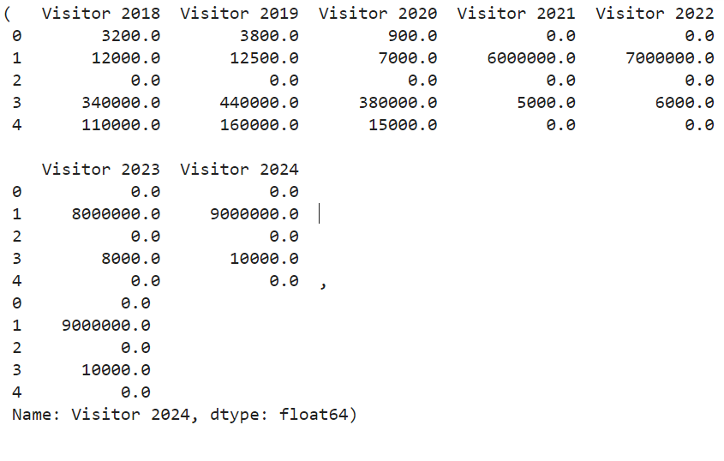

**Fig 3 Comparison Table of Model Accuracy Metrics**

**5. Prediction**

Overview:

Based on factors such as destination, city, type of attraction, time of year and visitor data, our tourist behaviour analysis system is populated with this data and uses machine learning algorithms to predict tourist trends in real time. By analyzing historical tourism data as well as integrating live data streams, the system enables users to know how many tourists you can expect and to predict their behaviour patterns with precision.

Real-Time Data Integration

Living data from tourism related APIs, databases, and real time sources are continuously integrated into its predictions. For example, it is live information on tourist visits, local events, weather conditions, and other things that affect tourist activity. The live inputs to the model serves to make the model a flexible input to changing conditions and provide accurate and dynamic predictions.

Prediction Mechanism

Using advanced machine learning algorithms such as regression models, decision trees, or neural networks, the system predicts various aspects of tourist behaviour, including

Expected Tourist Volume: It predicts the number of tourists visiting in a location particular.

Peak Visiting Times: Indicates popular times of the year, week, or day to visit for tourist.

Attraction Preferences: Takes care of which attractions will attract the most visitors. The machine learning model gets at it by using that the model can re learn from newly gained information from live sources, and learn how to predict things in the future from an old way of looking at things.

Information displays and surface elements

The presentation of the prediction results is done using a Streamlit library that provides simple and friendly functionality. Users can input key details such as:

Destination/City

Natural Landmarks, Cultural Heritage sites, amusement park.. Sources.

I point out that I date month (or season etc).

Relating to the environment these include: Social Factors — (optional) and Event or Weather Conditions (optional).

As per which, these inputs produce real time real time prediction of behaviours of tourists and consequent tourist numbers and trends in a real time, real, visual and actionable form. That is why the tourism professionals, the event planners as well as the destination managers can make planned decisions to utilise the available resources, the marketing tools or enhance visitors experience.

**6. Data Visualization**

In order to show various features and make the outcome more interpretable the obtained results are presented with the help of libraries like Matplotlib and Seaborn. Such tools are most effective when one needs to create rudimentary static charts for real-time analysis. They are useful when you are dealing with additional smaller or ‘static’ and non-interactive data sets associated with the tourist behavior; in these cases these tools provide straightforward visualizations of trends and patterns.

For more dynamic data, Plotly and Altair tools are used in this case. These tools are useful when html5 interaction – including zooming, hovering, custom filtering – is needed. They allow gaining better and more comprehensive information, particularly while operating with increased numbers of records, making the process of heat mapping and the analysis of tourist tendencies more flexible.

**7. Future Extensions**

Incorporating unstructured data to this model such as visitors’ feedback and reviews, local events and festivals, time of the year will further improve the model. Better still, these additional factors would serve to further strengthen and expand the predictability of the prediction model to the changed tourism dynamics so that the predictions become more exact and personalized as related to real time trends and external impact.

. 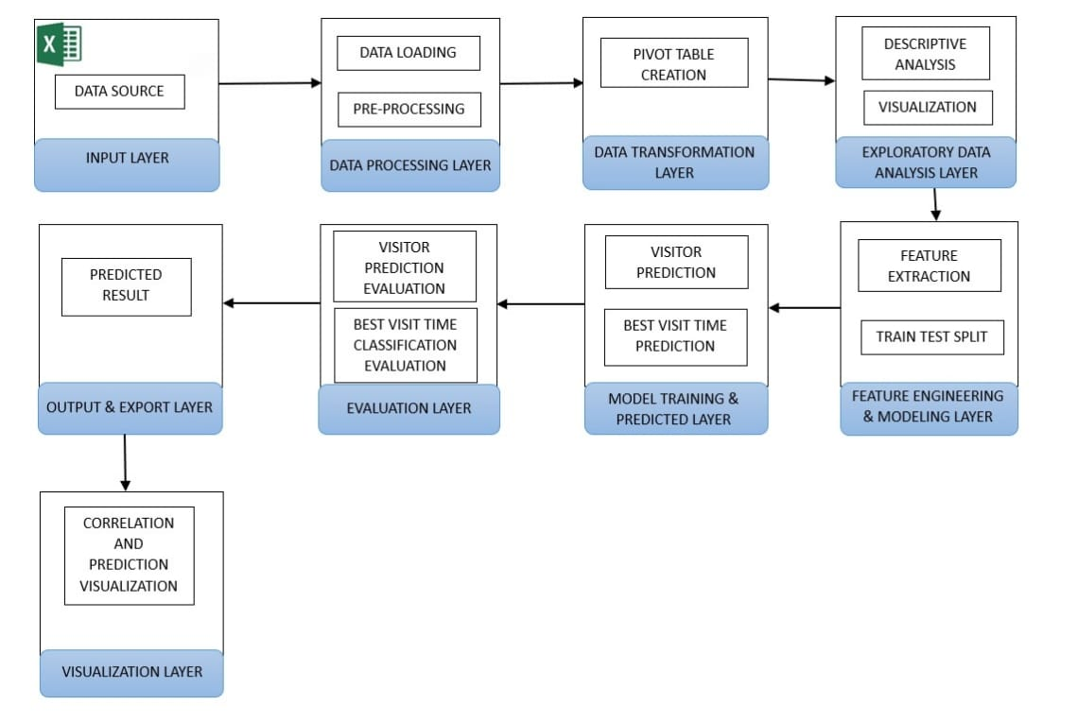

**Fig 4. Architecture diagram for Tourist behaviour**

## RESULT

For the predicted number of visitors in 2025, the resulting plot shows the predicted tourist footfall from each attraction clearly. This graph visualizes the anticipated patterns, which allow stakeholders to quickly see which destinations are expected to see huge increases or decreases in visitors. The data is presented through the plot in a format that facilitates planning for tourism management strategy, in order to allocate resources effectively and select areas for focus of marketing efforts based upon the most promising high growth area

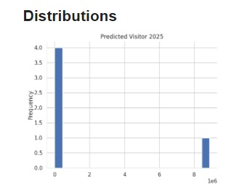

**Fig 5.Predicted Visitor in Distribution**

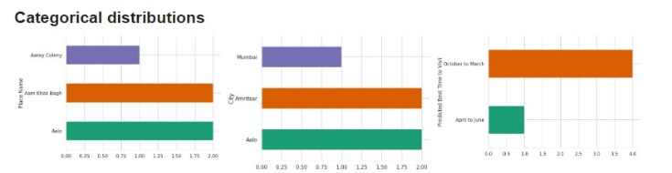

**Fig 6.Predicted Visitor in Categorical Distribution**

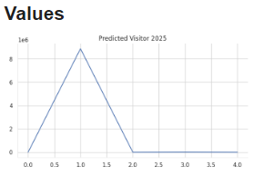

**Fig 7.Predicted Visitor in Graph Form**

Based on data from 2001 to 2024, the analysis predicts the number of visitors for 2025. To generate output, a column reflecting the counts visitors are expected to visit various tourist attractions in 2025 is added. The availability of the forecast gives tourism stakeholders an edge to plan and allocate budgets for the next year.

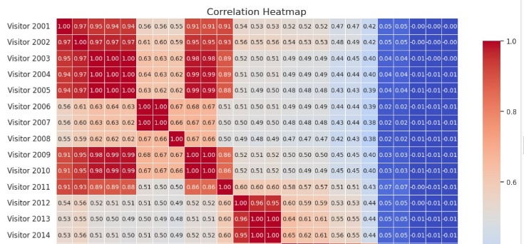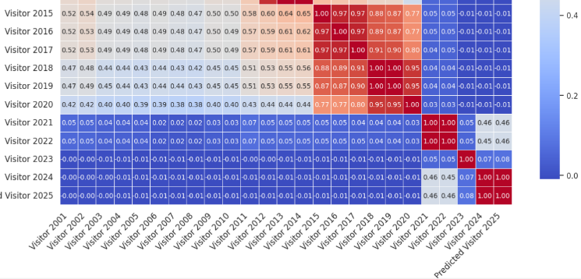

**Fig 8.Visualization of confused graph**

## CONCLUSION AND FUTURE SCOPE

## CONCLUSION

However, the success of this project lies in its use of machine learning algorithms in conjunction with Google Colab and Apache Spark to predict the coming year's tourists amount to visit a destination. The model uses a comprehensive dataset -- factors like location, season, attraction types and visitor trends -- to predict future tourist behavior. Apache Spark's distributed processing capabilities enable seamless flow of data collection, pre processing and prediction resulting in actionable insights for tourism operators and stakeholders in order to improve planning and resource allocation. Using Google Colab for development and Apache Spark for large scale data processing shows machine learning is continuing to play an important role in forecasting tourism trends — giving the flexibility and scalability of small and large datasets in tourism.

FUTURE SCOPE

A few improvements for future can be done. Prediction can become more accurate and up to date by including live event feeds or more real time data sources like live event feeds, transportation data or visitor check ins. Further improving the accuracy of long term tourist forecasting can be integrated with future advanced machine learning models such as LSTM or ensemble methods into Apache Spark MLlib. The model could be expanded to use international tourism trends and economic factors in order to capture international influences on tourist behavior. Beyond that, ensuring that the visualization dashboard is using interactive features that resonate with various stakeholders will make it possible to arrive at more persuasive decisions, enhance marketing strategies and management of resources.

## REFERENCES

[1] Zheng Cao, Heng Xu, Brian Teo Sheng Xian, Chinese Tourists in Malaysia: Tourism Digital Footprint for SpatioTemporal Behavior Analysis, 2022

[2] Muhammad Iqbal, Jingyi Xu, Li Renjie, Behavior Analysis of Photo Taking Tourists by Deep Learning over Latent Dirichlet Allocation Combined with Kernel Density Estimation, 2024

[3] Changfeng Jing, Meng Dong, Mingyi Du, Yanli Zhu, Jiayun Fu, Fine-Grained Spatiotemporal Dynamics of Inbound Tourists Based on Geotagged Photos: Beijing, China, 2020:

[4] Jie Yin, Yahua Bi, Xiang-Min Zheng, Ruey-Chyn Tsaur, Safety Forecasting and Early Warning of Highly Aggregated Tourist Crowds in China, 2019

[5] Tao Peng, Jian Chen, Chenjie Wang, Yanshi Cao, A Forecast Model of Tourism Demand Driven by Social Network Data, 2021

[6] Xinyu Wu, Zhou Huang, Xia Peng, Yiran Chen, Yu Liu, Building a Spatially-Embedded Network of Tourism Hotspots From Geotagged Social Media Data, 2018

[7] Lina Zhong, Liyu Yang, Jia Rong, Haoyu Kong, A Big Data Framework to Identify Tourist Interests Based on Geotagged Travel Photos, 2020

[8] Shabir Ahmad, Israr Ullah, Faisal Mehmood, Dohyeun Kim, A Stochastic Approach Towards Travel Route Optimization and Recommendation Based on Users Constraints Using Markov Chain, 2019

[9] Shah J. Miah, Huy Quan Vu, John Gammack, Michael McGrath, A Big Data Analytics Method for Tourist Behaviour Analysis, 2016